/\* Ashok IPBC MoProject R1SP2 Story3 Lab 7.26.19\*/

Homework:

4. Complete R1:SP2: Story 3 – Load the data into the Staging Database. Explain the entire process

with explanations &amp; screenshots.

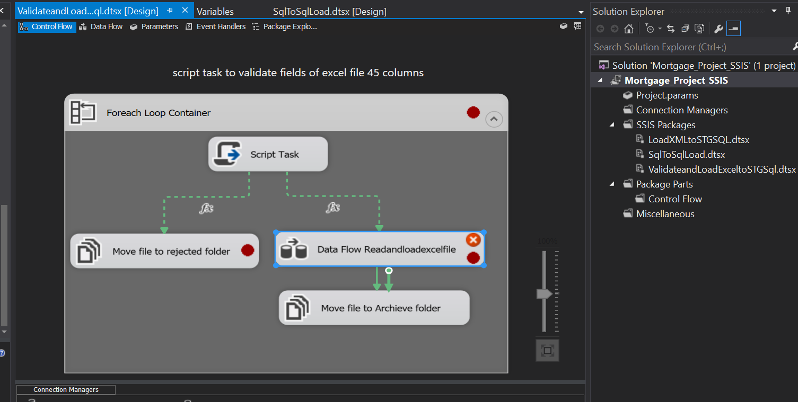

We use foreach loop container for loading multiple excel file to ssis and finally to Database table.

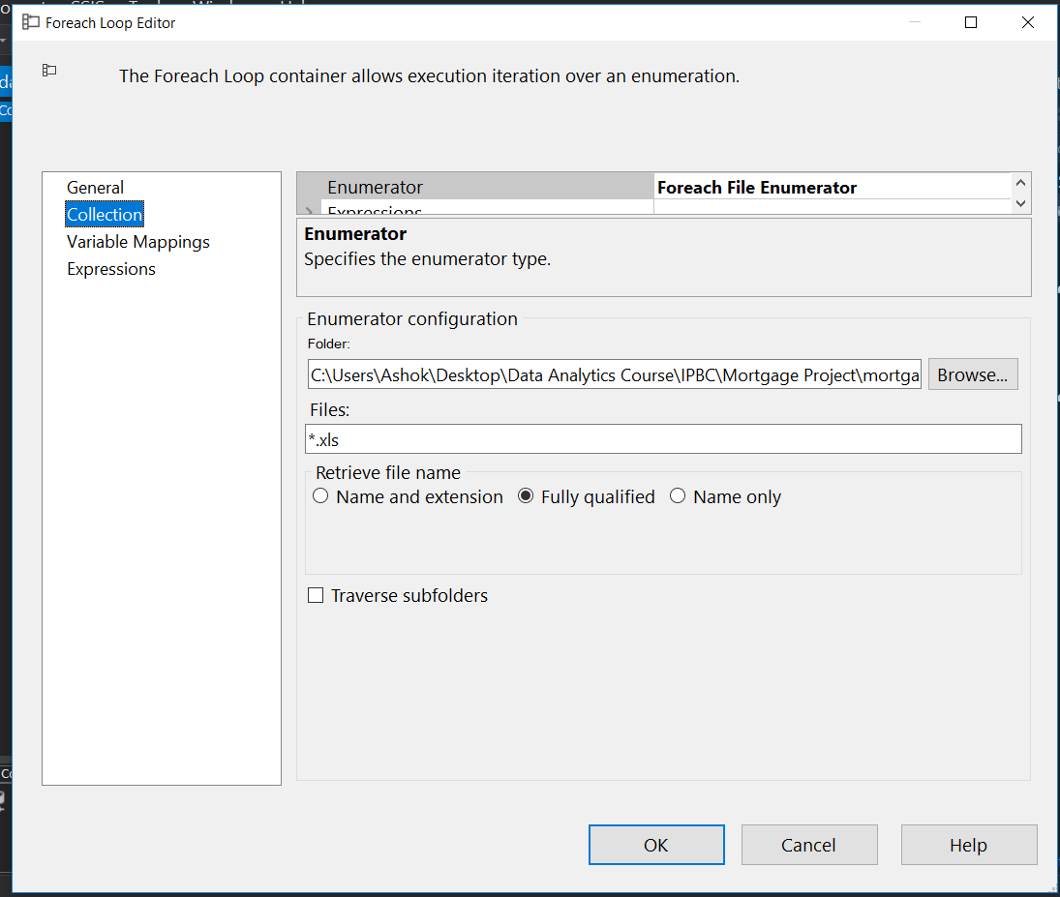

The enumerator of for each loop contain for different excel files from syste,.

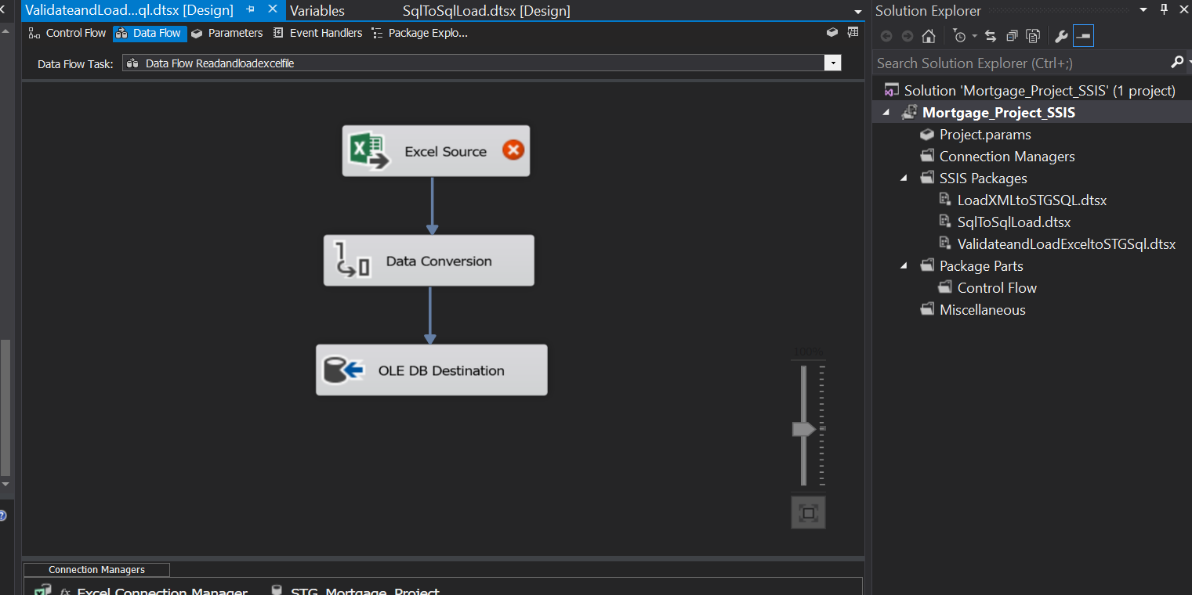

This is dataflow of excel source to data conversion to ole db destination.

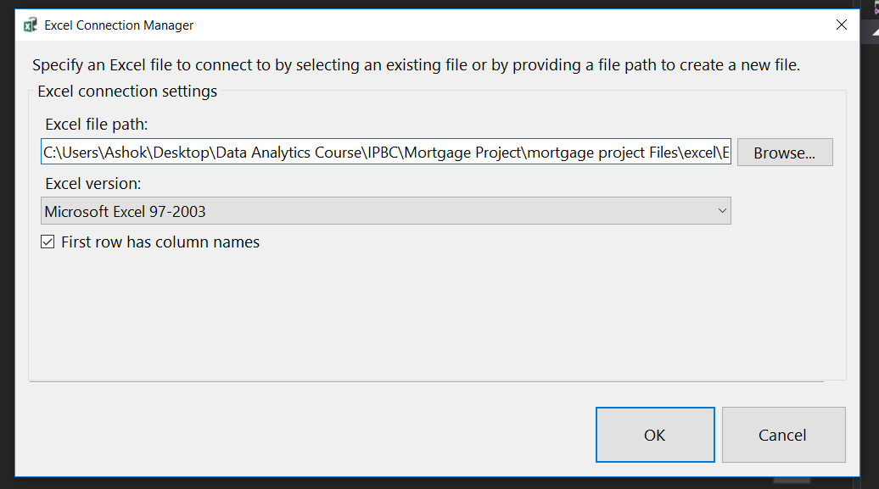

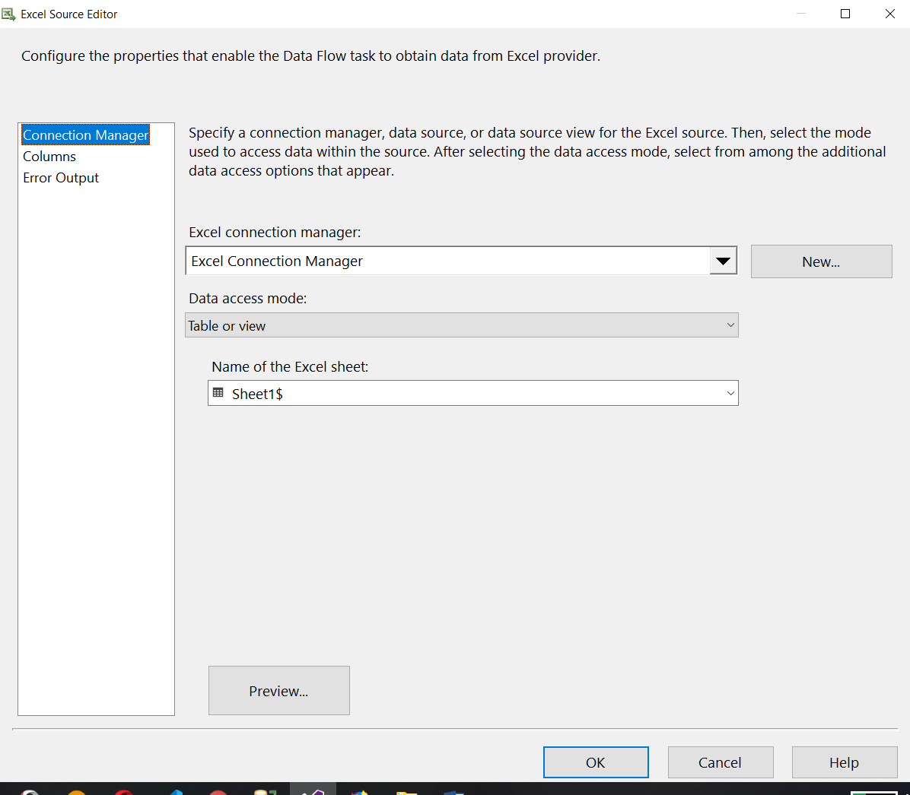

This is configuration for excel connection to excel file of system. and its excel sheet

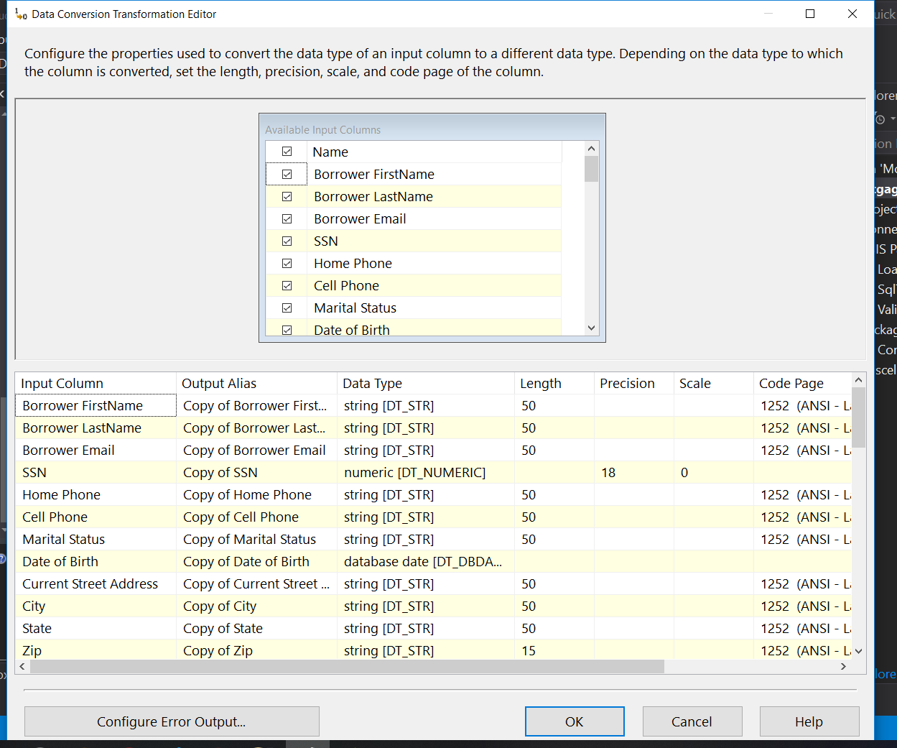

Above image is for data conversion transformation for different Unicode to non unicode columns.

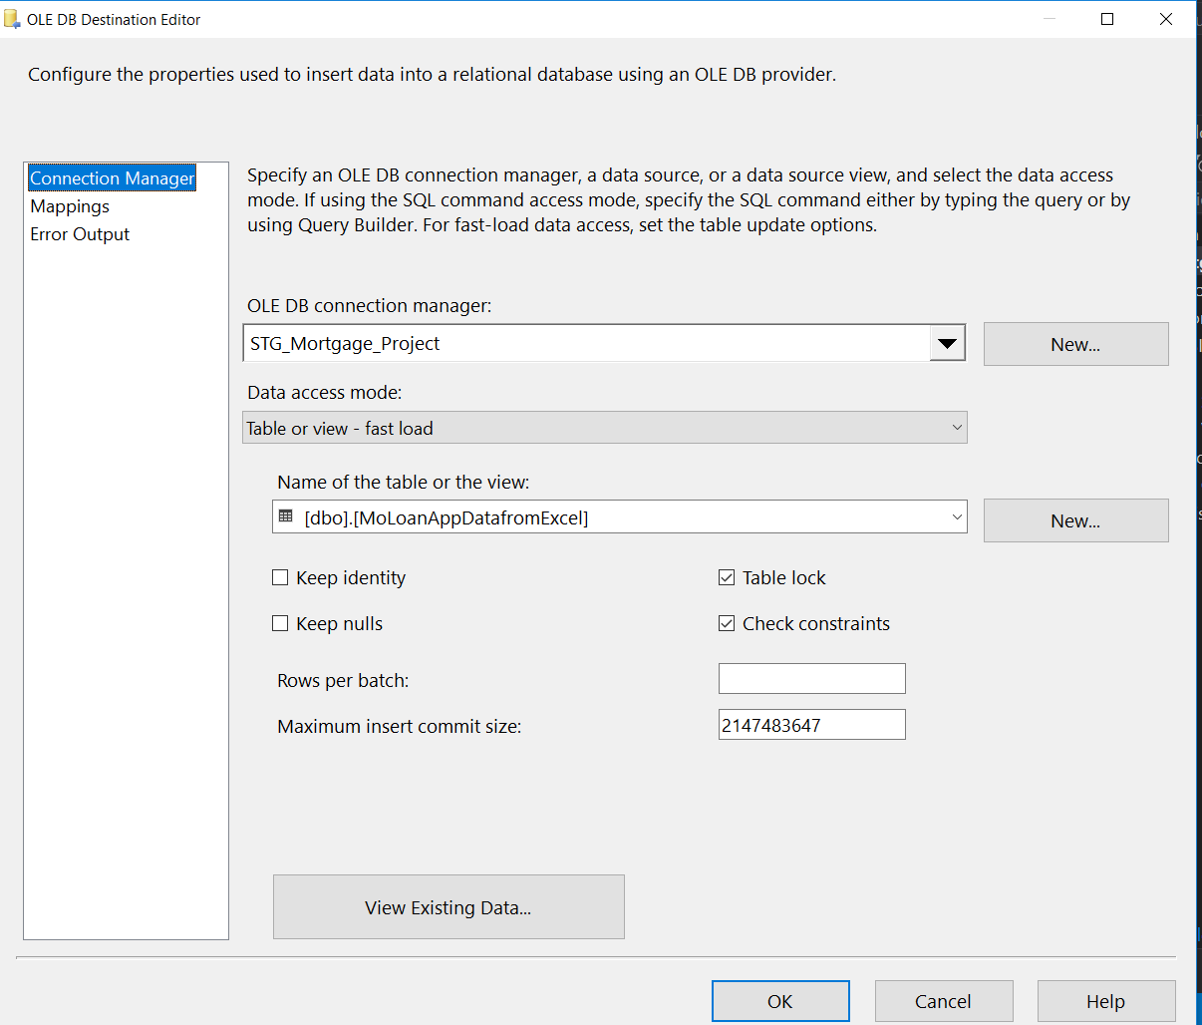

Above image show the oledb connection manager detail for oledb server and it database with specific table where we want to load data from excel files.

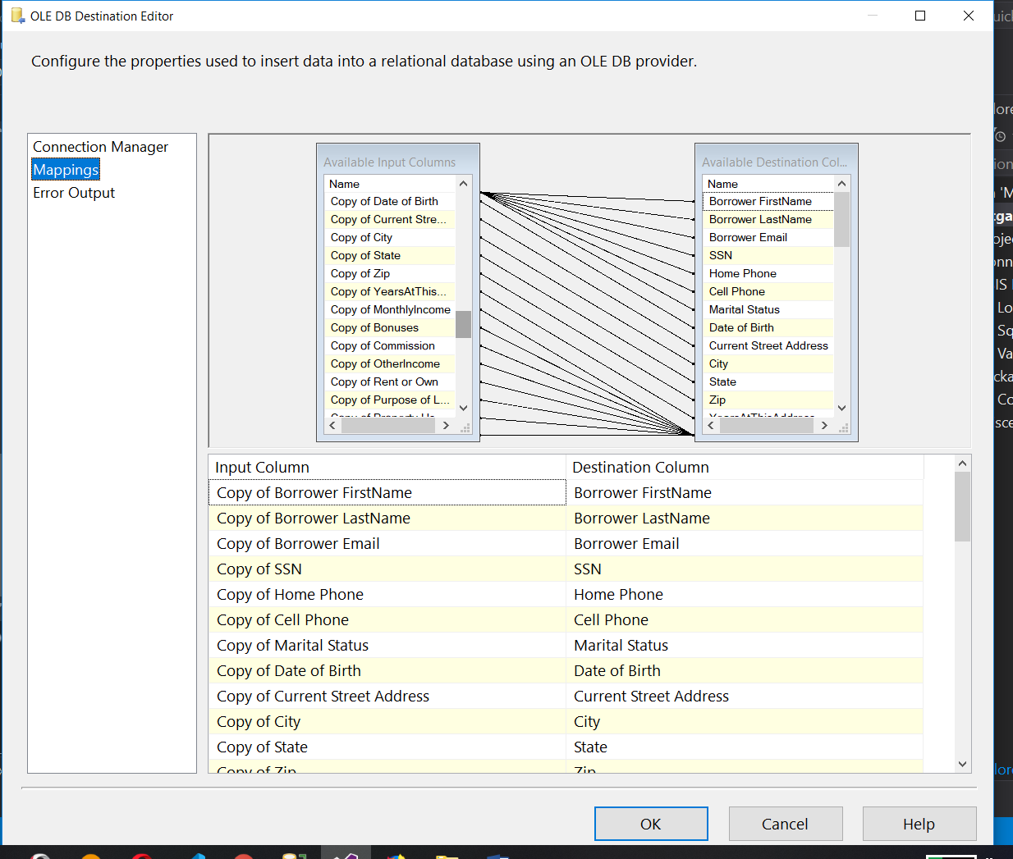

Above image shows the mapping of columns in ole db connection manager for data conversion column to table columns.

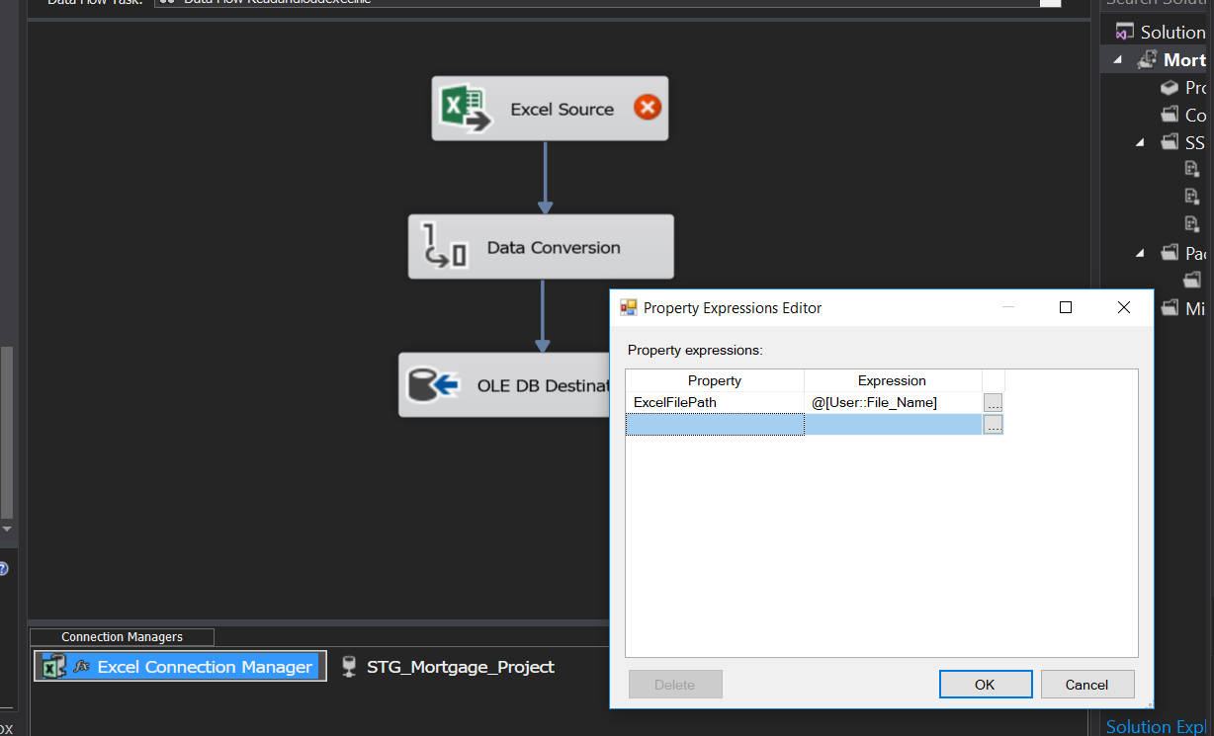

We set excel connection mangers excel file path property to variable value by changing it’s property.

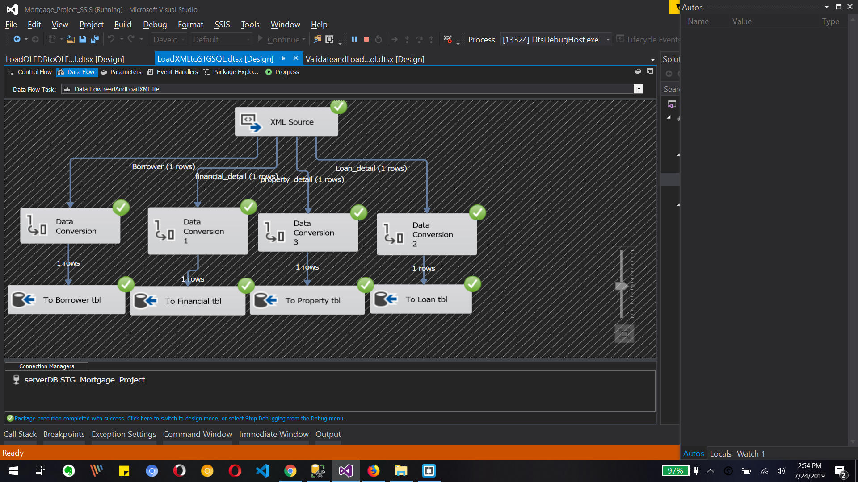

Above image is for xml file load to database tables. Xml source to data conversion to Unicode to non Unicode data and then load it to database tables.

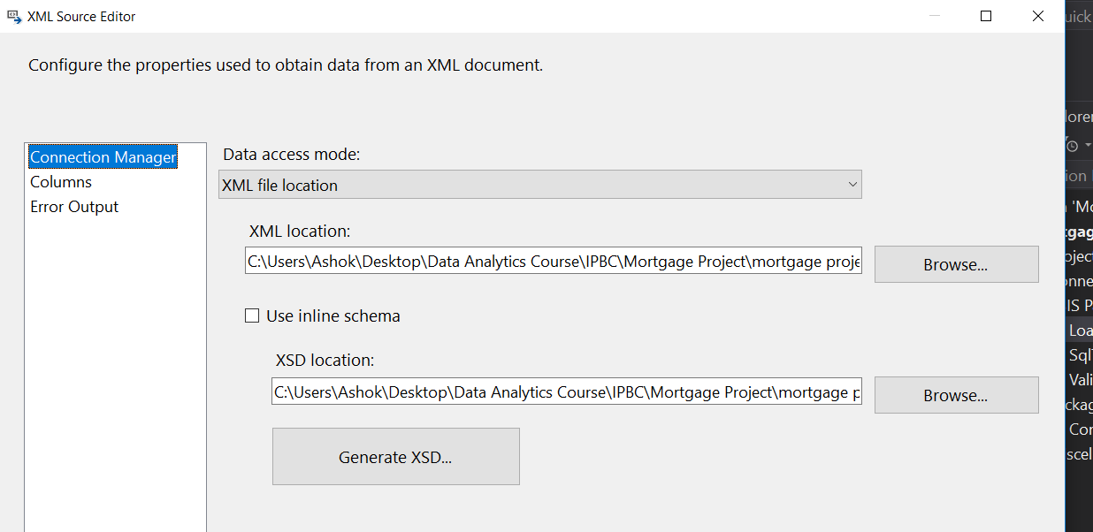

Above image is xml source editor for selecting xml location and it’s xsd location from system.

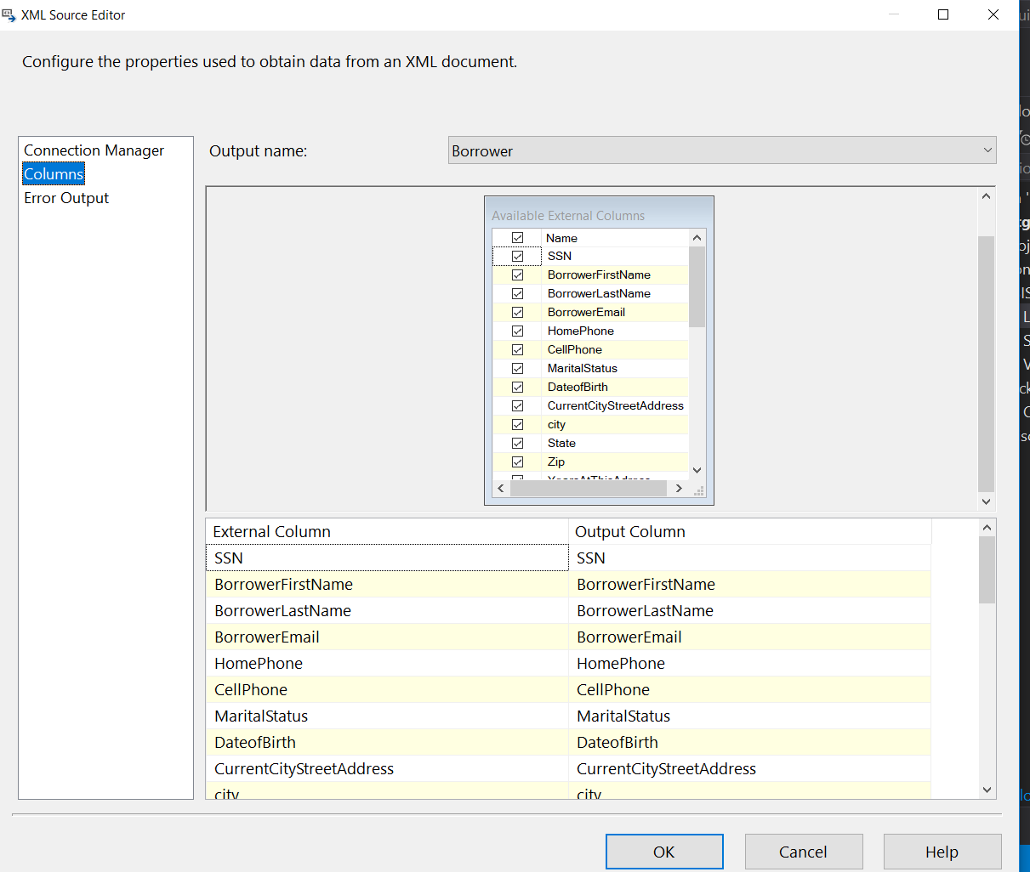

Those are the columns which we need to load to dabase table so we selecte them.

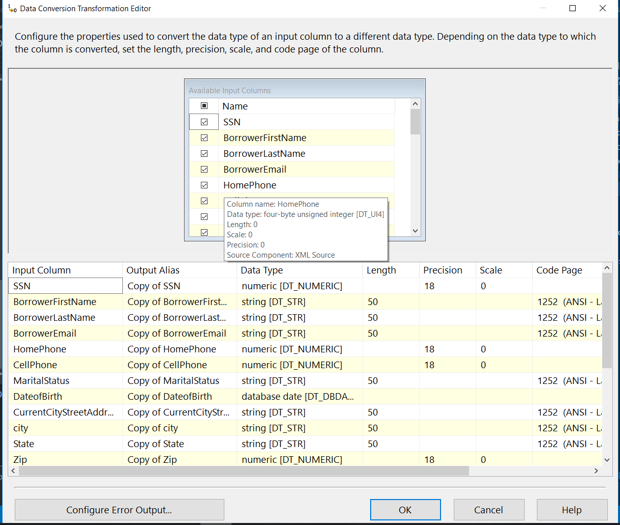

Image shows the data conversion editor for unicode to non unicode datatype conversion.

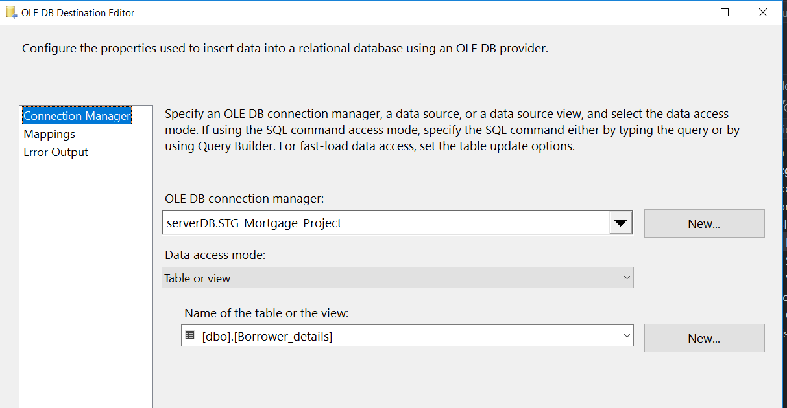

Above image is for ole db destination editor for selecting database and table.

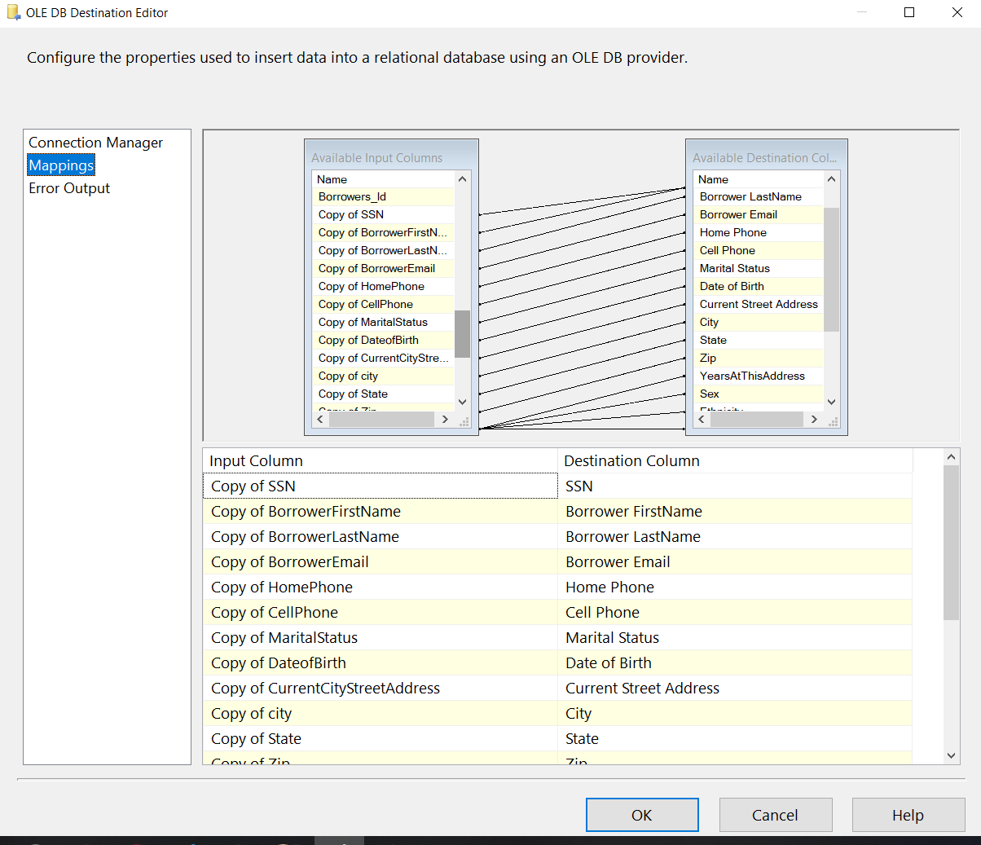

WE map the columns from data conversion to table columns as show in image.

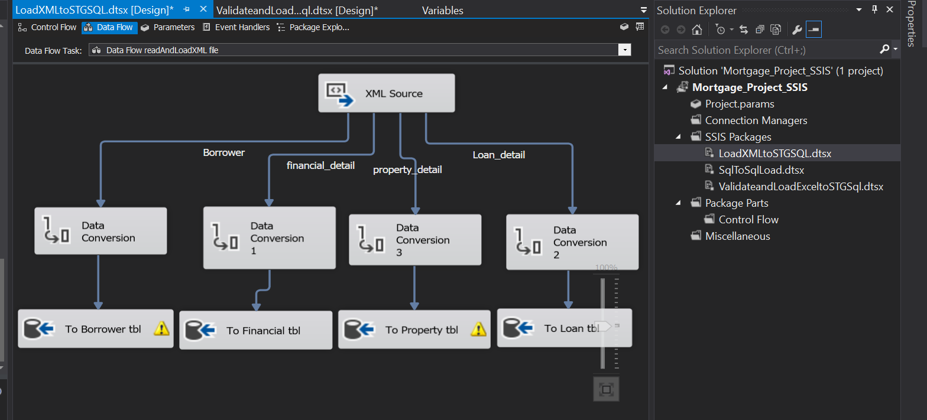

Above image shoes all tables with different ole db table so we can load all table with different columns from xml source file which have all columns together. We porcess the same flow as shown in above flow for borrower table.

* OLEDB data table to oledb table load

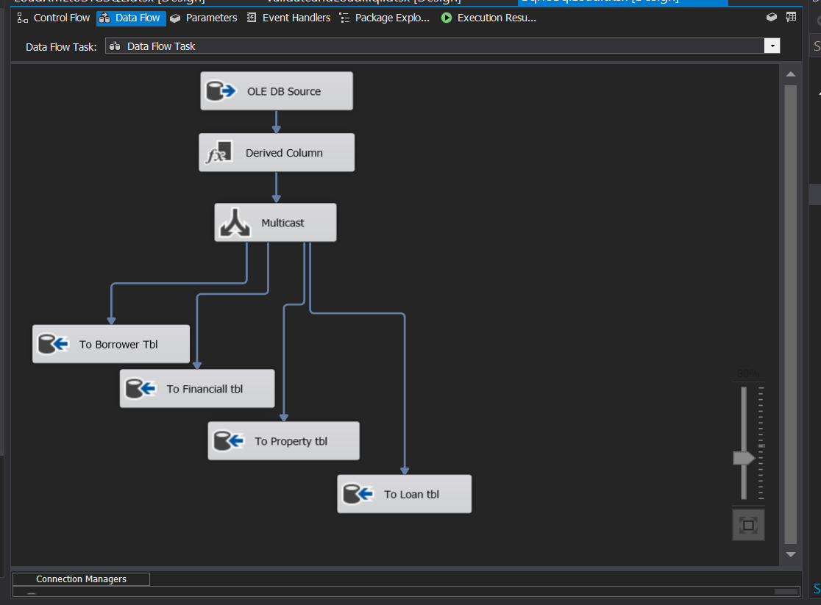

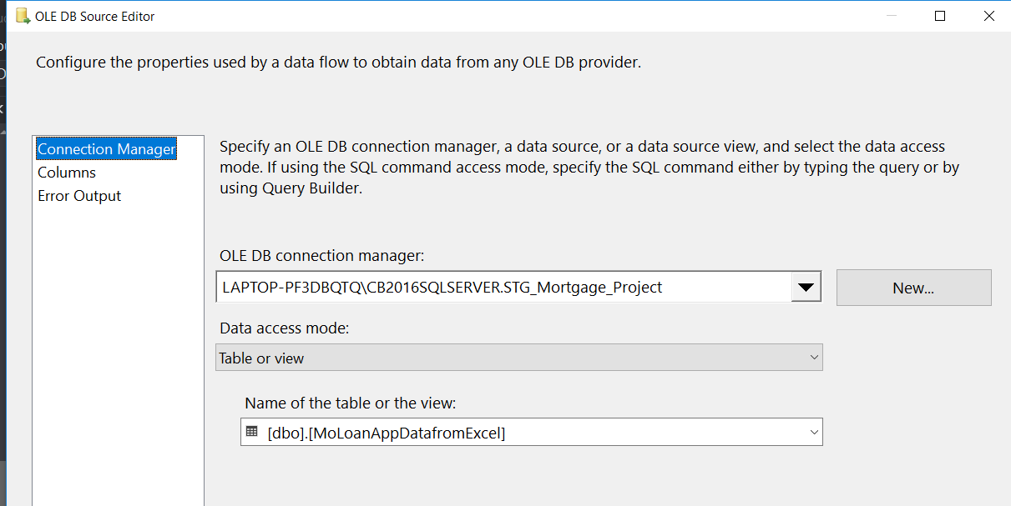

WE configure ole db source for connection to server and database and it’s table.

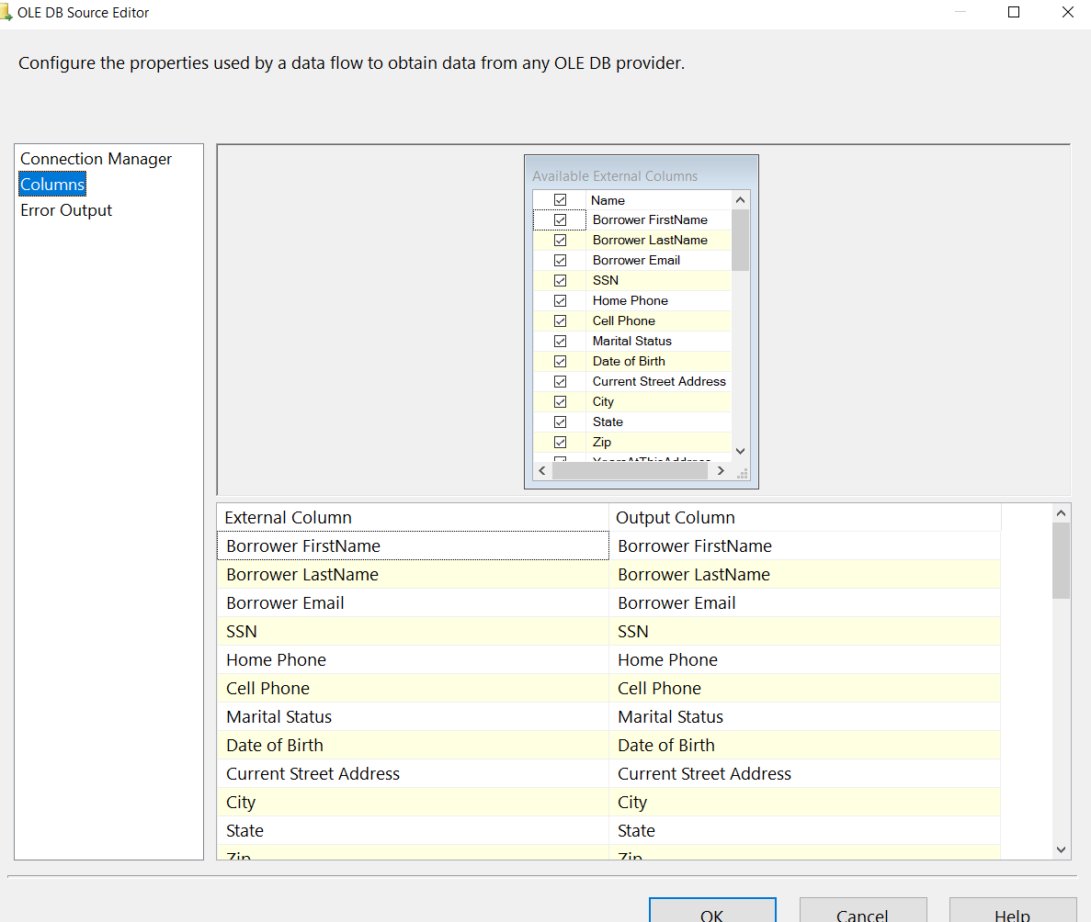

Above image shows the columns of table which we need to load to other tables.

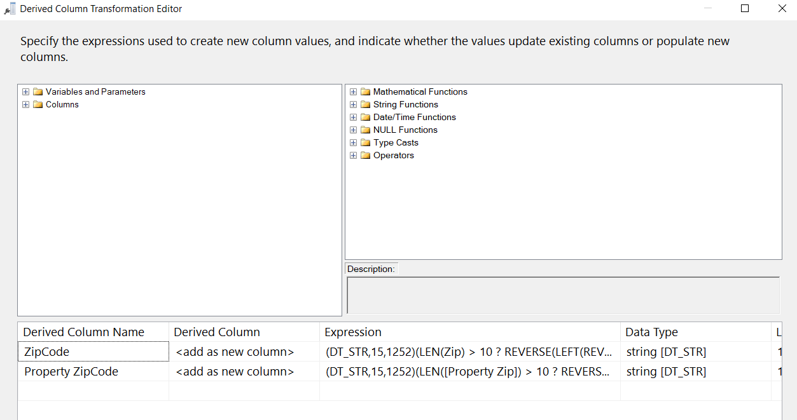

We use derived column transformation to create two new columns as ZipCode and PostalZIpCode

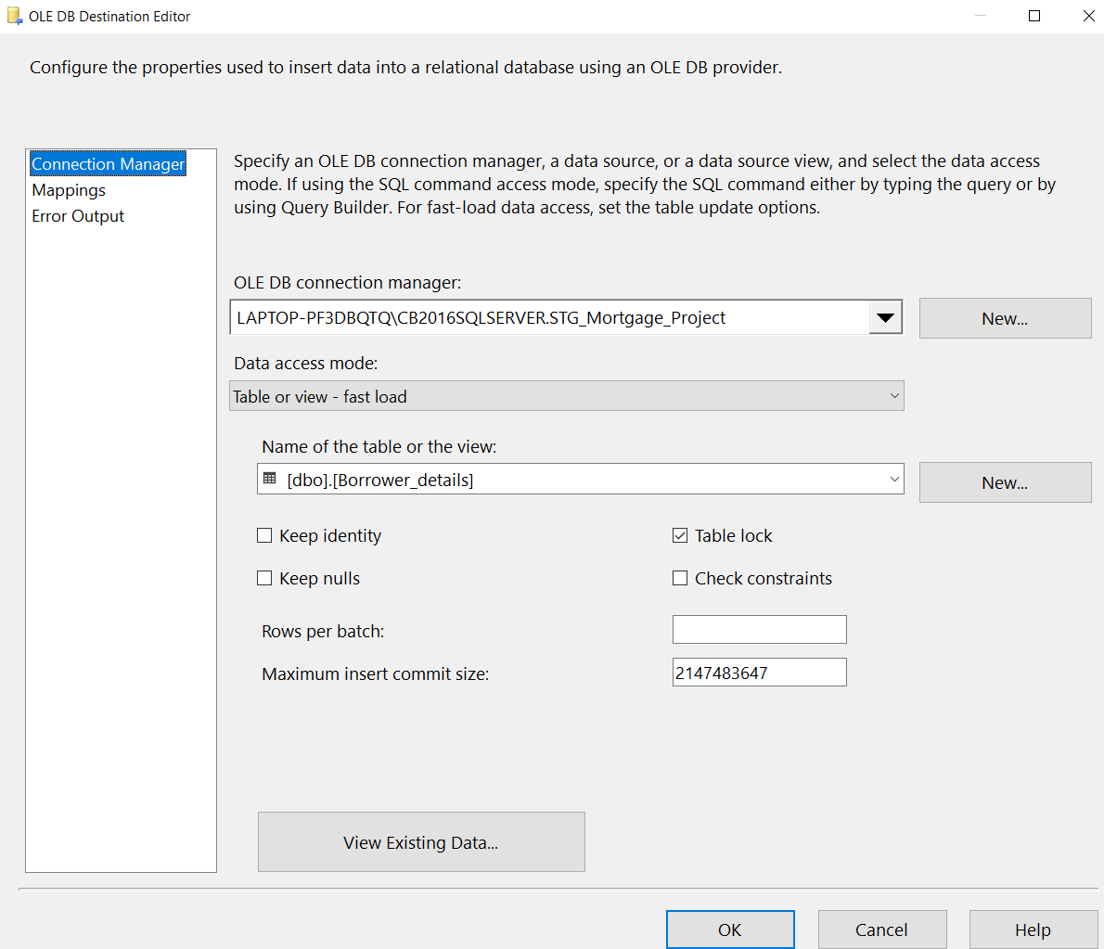

Above image shows the ole db destination editor where we select server, database and table with sheet to load data into from other table.

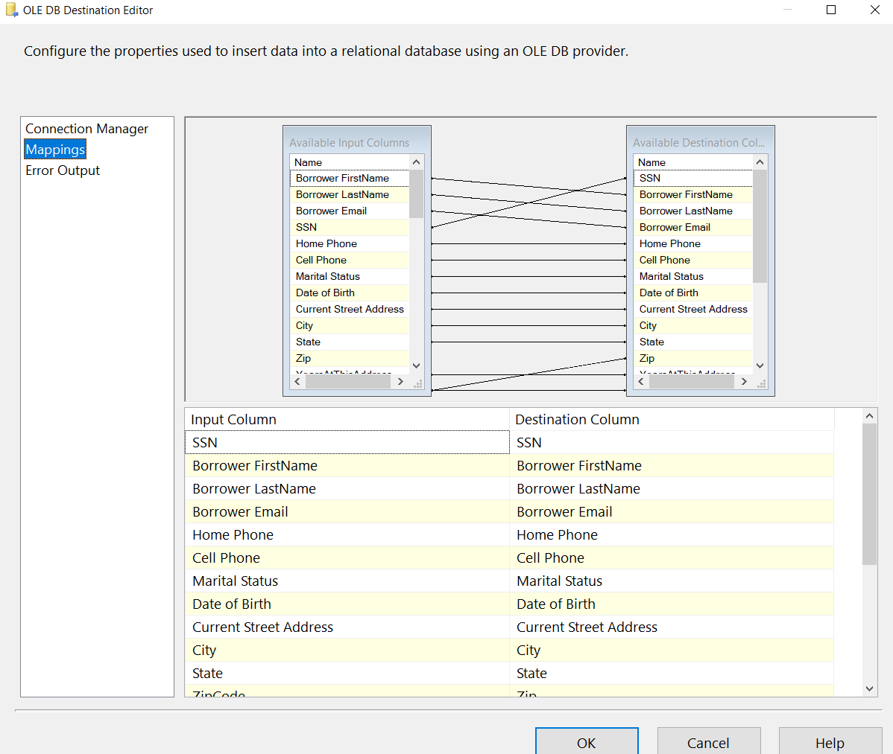

Mapping for the columns from upstream to downstream table. We select needed columns as our destination table have. Now we do those steps for rest of tables to load data with the help of multi case where data is coming from oledb table.

Video(s) to Submit:

What to Submit:

1. Copy and paste the link to your video(s) as part of your homework.

1. IPBC Status Update : Mortgage Project Story 1 – 3

<https://app.colaberry.com/app/ipbc/videos?user=31221&category=12>



1. 2. SQL BI Interview Questions: SSIS – How do you load multiple files in EXCEL

<https://app.colaberry.com/app/ipbc/videos?user=31221&category=33>

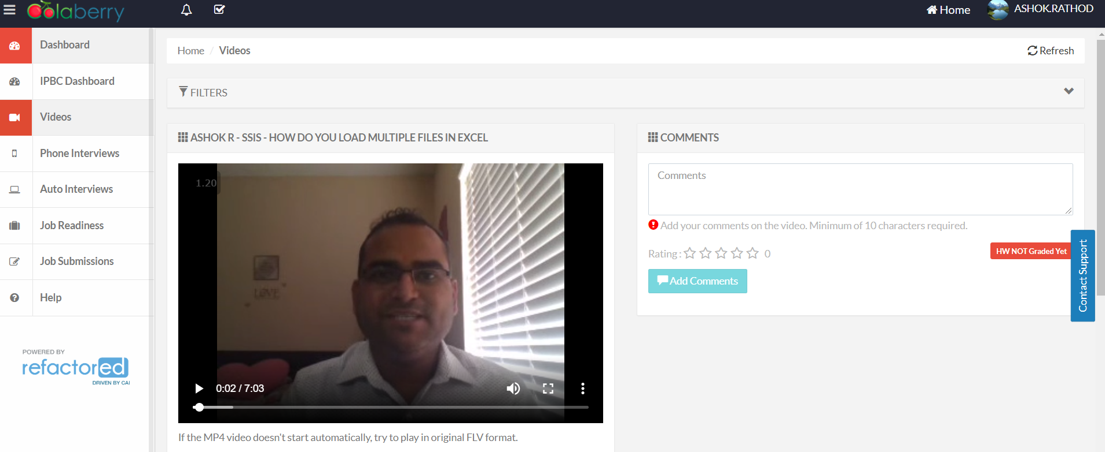

1. Watch, Comment &amp; take screenshots of your comments from 3 other videos on the same topic (per question). Comments must be 20+ characters. Leave comments based on presentation, delivery and/or technical details. Your critiques will help you be more conscious of your own videos. (3 comment screenshots per Video Question)

* Mortgage Project Story 1 – 3

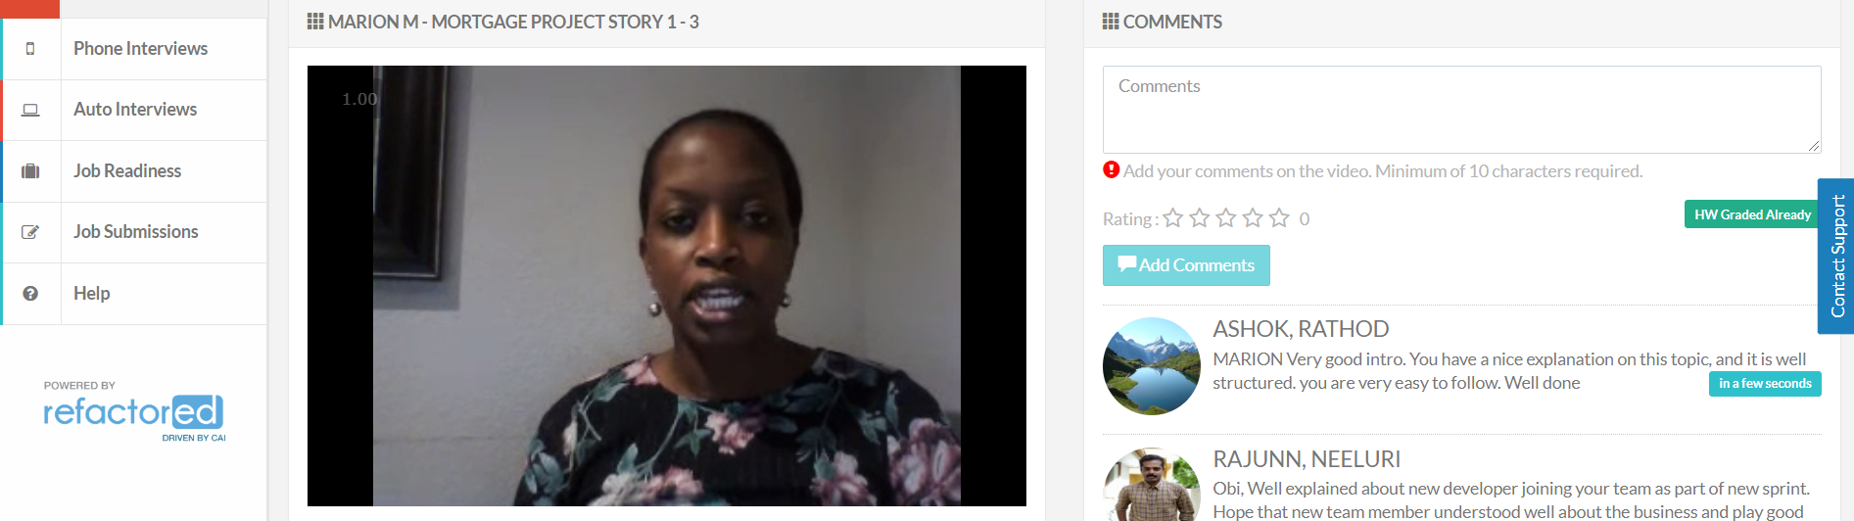 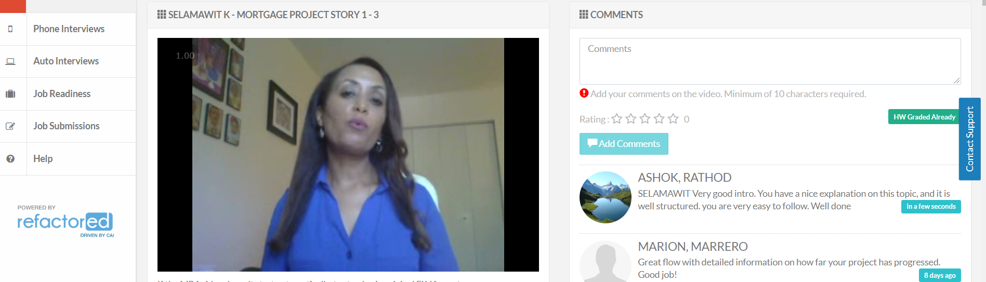

* How do you load multiple files in EXCEL

